**INTRO:**

In this iteration we are firstly login the admin and allowing the admin to perform its task .In this iteration admin will approved the certain event and admin will also approve the event in the event log. Admin also has access to view the feedback of user. In this iteration all the user who are sign in can give the feedback.

**Boundary Value Analysis**

**Username and Password Fields**

Boundary Value analysis is a testing technique accuracy of software system .In our software application we apply boundary value analysis in checking validation of username and password in login system. This analysis basic purpose is to find what valid or invalid ranges can be for our software application to ensure that our system behaves correctly under certain circumstances.

**RULES**

**Login:**

* Username should have at least 3character and maximum 30 character

**Password:**

* There should be at least 5 character.
* It should not contain any spaces.
* It should at least contain one upper case and one lower case.

BVA

1. Username Field:

* It should have character less than three character
* It should have character more than 15.

2. Password Field:

* It should have contain less than 5 character
* It should have contain any space
* It should not contain any upper case
* It should not contain any lower case

|  |  |  |  |
| --- | --- | --- | --- |
| Serial number | username | password | Result |
| 1 | ABBASI | Anbic!jb | fail |
| 2 | ab | A2!11 | fail |
| 3 | aimlik | Hello hello | fail |
| 4 | Aaimlik | aa112211 | Fail |
| 5 | aaaaaaaaaaaaaaaaaaa | Aa1122!11 | Fail |
| 6 | aaimlik | hello | Fail |
| 7 | Aaimlik | Ahhh6834 | pass |
| 8 | aaimlik | AAIMLIK | fail |
| 9 | aaimlik | Aak2 | fail |
| 10 | aaimlik | aaimlik | fail |
|  |  |  |  |

Conclusion

By testing inputs at the boundaries of valid and invalid ranges, we ensured that the system behaved as expected and provided appropriate feedback to users.

**ARCHITECTURE**

3 Layer architecture

USER INNTERFACE

BUSINESS LOGIC

DATABASE

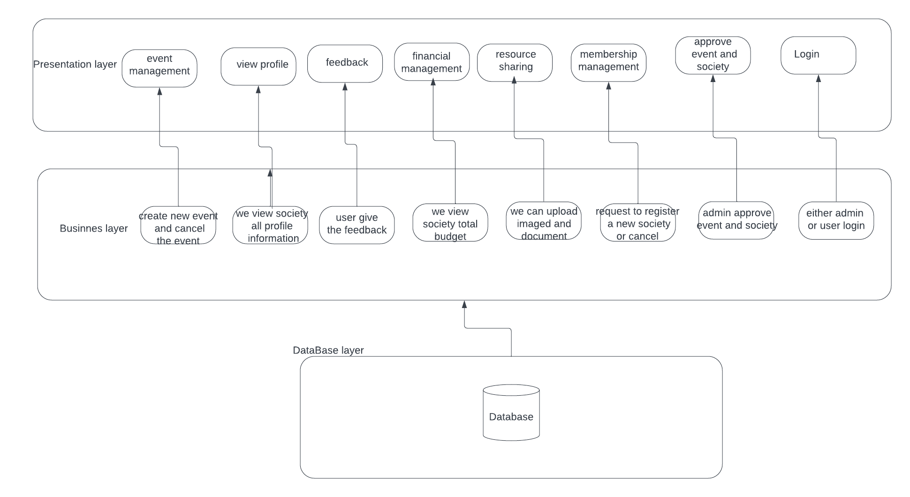

I have adopted three layer architecture for my project as it has presentation layer, business layer and database layer.

**PRESENTATION LAYER**

I have drawn the interface for my project plus it includes functionality of forms like event management, viewing society profiles, giving feedback, financial management, resource sharing, membership management, and approving events and societies. This presentation layer focus on the interface

**BUSINESS LAYER**

It act as intermediary between database and presentation layer this layer hold the logic to implement the functionality that get updated in the database

Manages the creation and cancellation of events, viewing comprehensive society profiles, collecting and managing user feedback, viewing society budgets, uploading images and documents, and handling society registration requests

This all logic is implemented in business layer

**DATABASE LAYER**

**We are** managing db through sql server .sql server has all the necessary table that are needed to implement the business layer logic

**SUB STORIES**

**1: Membership Management**

**User Story:**

1. 1. As a Student, I want my system to give me prompts if my request has been approved
2. As a Student, I want to see the list of registered socities
3. As an Admin, I want to see the schedule log for the socities

**2: Resource Sharing**

**User Story:**

* 1. As a student, I want to see the financial resources of every society
  2. As an admin, I want to be updated with the financial resources
  3. As a manager, I want to be able to upload the resource details from my system

**3: Financial Management**

**User Story:**

1. As a Manager I want to view and manage the finances of my society.
2. As a Student, I want to view the finances used by other societies.
3. As an admin, I want to be updated on society finances
4. As an admin, I want to approve a society’s finances.

4: **Event approved:**

**USER STORY**

**When** user login it request for the event, but event is not created unless it is approved by admin so admin login and view the event

SUBUSER STORY:

As admin login and view there are two option over there if admin select certain event and then click on approved button then tat event get approved

**5:Feedback**

**USER STORY**

When certain user login they can give feedback and that feedback is view by admin

SUBUSER STORY:

User login and click on the feedback button

Then the person will first select the society those feedback it want to give

Then it will write the feedback that will be updated at the db

6**: Society approve**

**USER STORY**

When user login there is a form of society management when they can request for society approval

SUBUSER STORY:

Admin login and can view the new society that are waiting for his/her approval

The society that admin want to approve ,admin just need to click on approved button that society will get inserted and new society will be form

**7 User Authentication:**

**User Story:**

1. As a student, I want to login the system with my email id and password so that I can login the system with the same credentials that I use for other university softwares

**Sub Story**

1. As a student, I want to the login button to be near the login form so that I can fill the form with ease
2. As a student, I want the system to authenticate my email id and password from its database.

3. As an admin officer, I want to login the system with my university email id and password so that I can login the system with the same

credentials that I use for other university softwares

**Sub Story:**

1. As an admin officer, I want the system to remember my login id and password so that I can access the system with ease.

**8: Schedule Event:**

**User Story:**

* + 1. As a student, I want to request the scheduling of an event so that the admin can approve it in a minimum time’s notice.

**Sub Story:**

* + - * 1. As a student, I want to see the list of all the scheduled events so that I can keep myself updated through this software
        2. As a student, I want to my event request to be approved quickly so that I can manage and time my event quickly.
    1. As an admin officer, I want to view the event requests upon login so that it saves my time.

**Sub Story:**

* + - 1. As an admin officer, I want to see the event request form to be in concise form so that it saves my time and the student’s time.

**9:Manage Society Profile:**

**User Story:**

* + 1. As a student, I want to manage the credentials of my society profile so that the university remains aware of our status.

**Sub Story:**

* + - 1. As a student, I want to see my society’s portfolio when I search for my society so that everyone is recognized of our efforts.

* + - 1. As an admin officer, I want to view the society portfolio on my interface so that I can be aware of a society’s performance.

**SCREENSHOT**

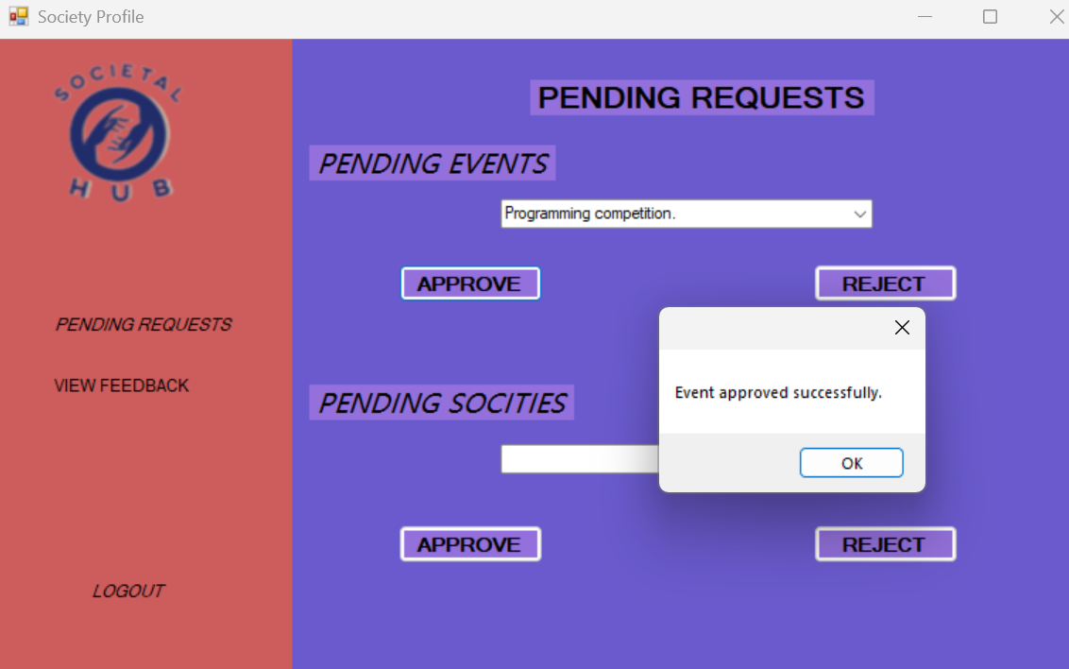

**Here admin first logic an**d then selectt the society that he want to approved and as soon as he click the approve button new event is created

**RESOURCE SHARING:**

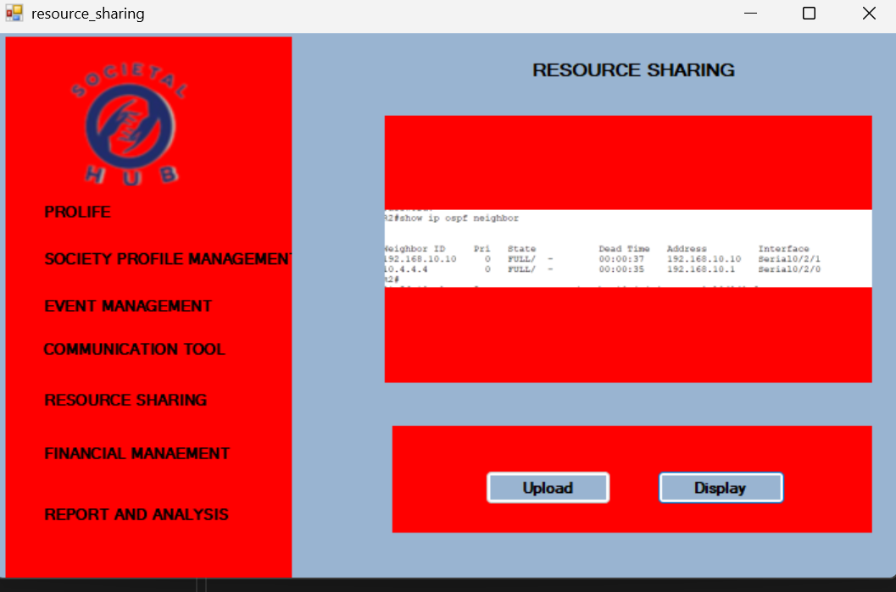

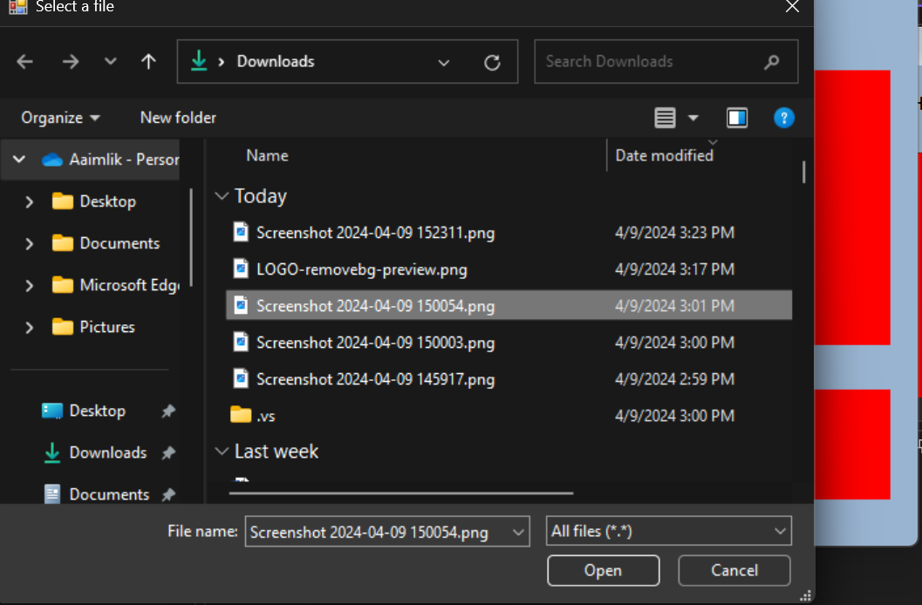

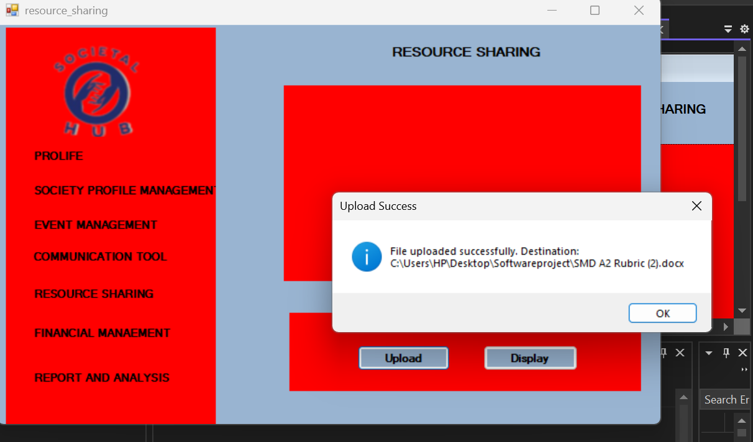

**FIANANCIAL MANAGEMENT**

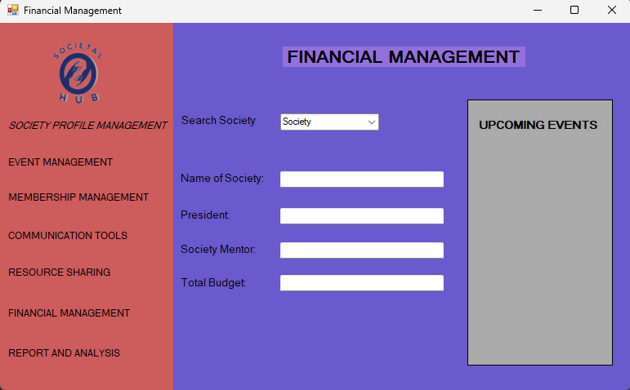

**MEMVERSHIP MANAGEMENT**

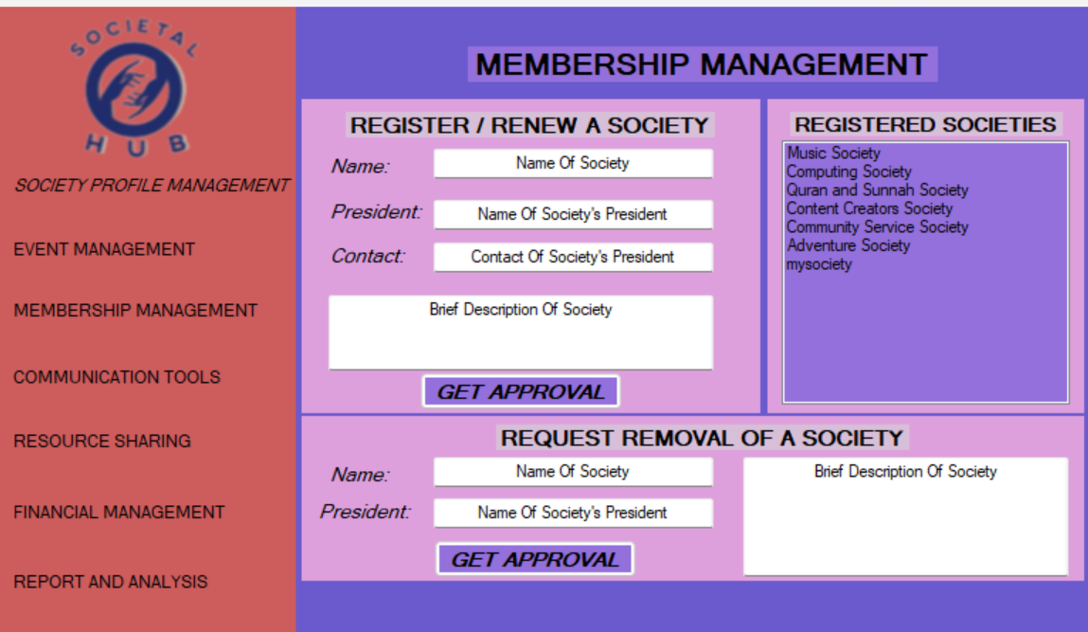

**LOGIN**

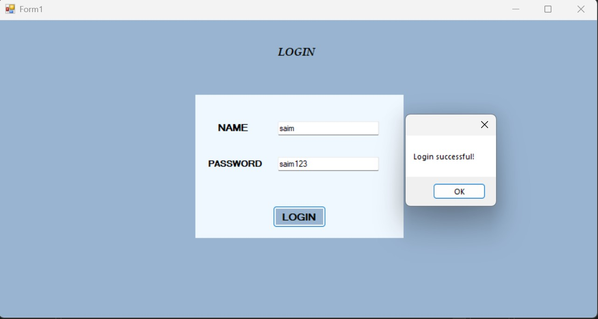

**EVENT MANAGEMENT**

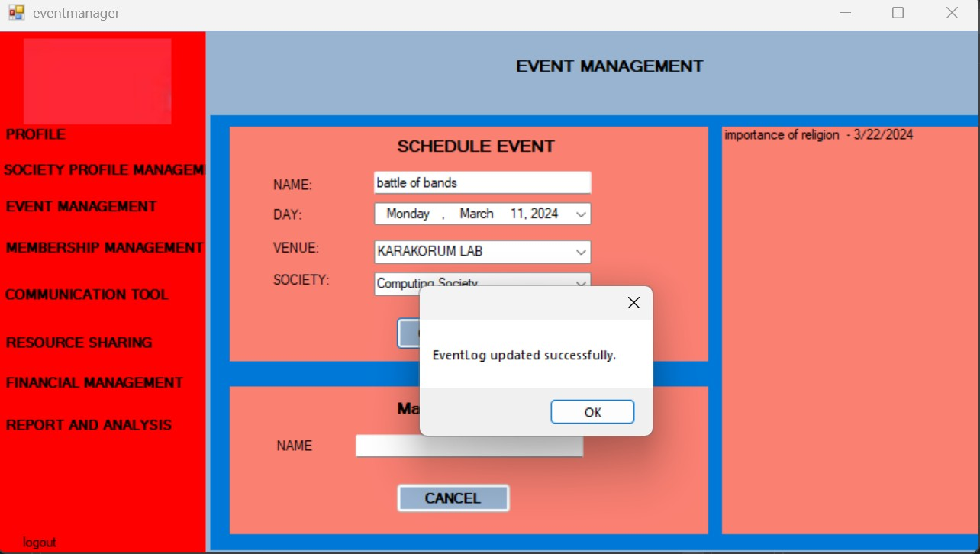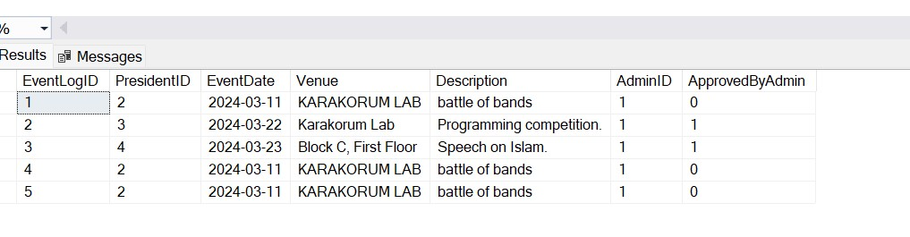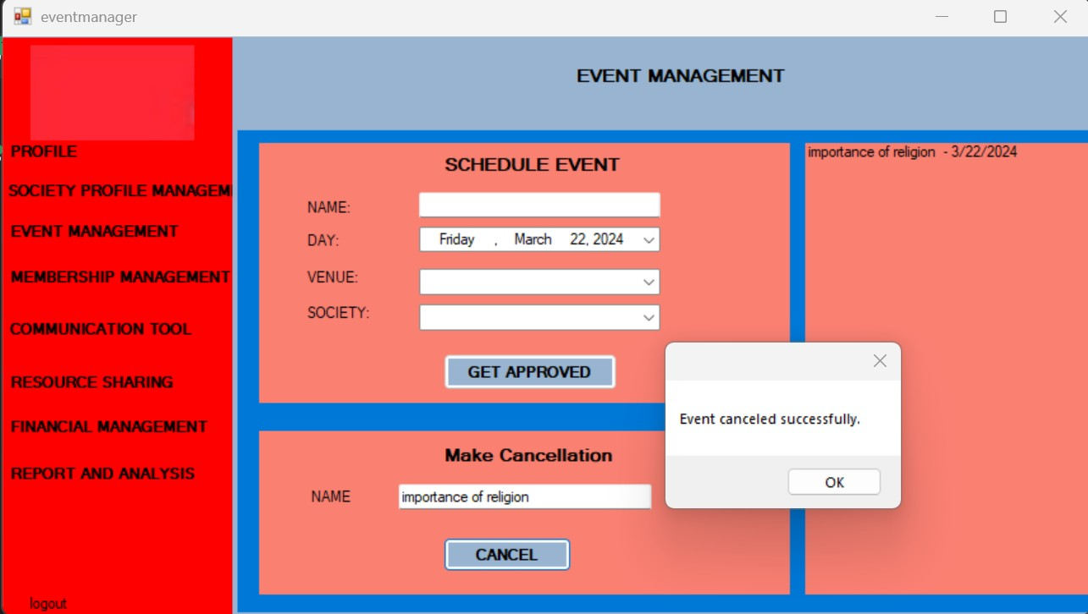

**SOCIETY PROFILE**

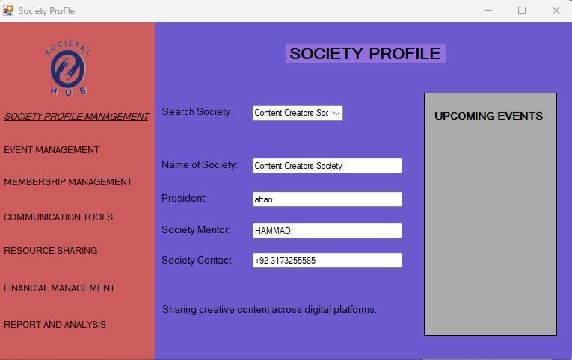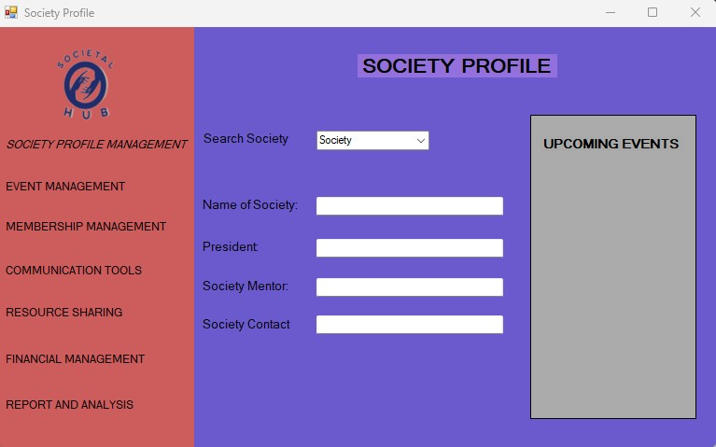

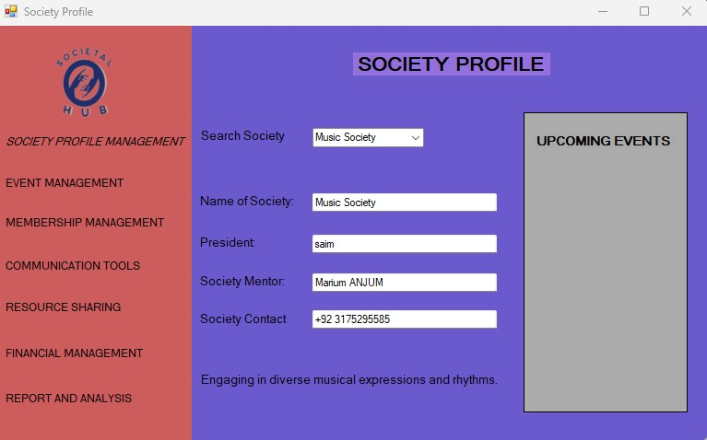

**ADMIN PROFILE**

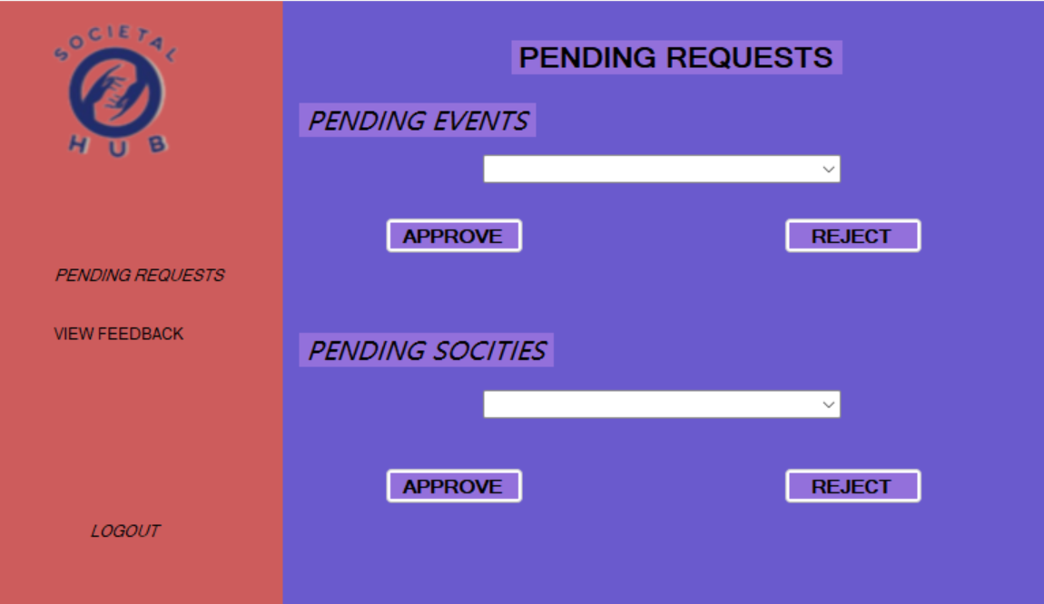

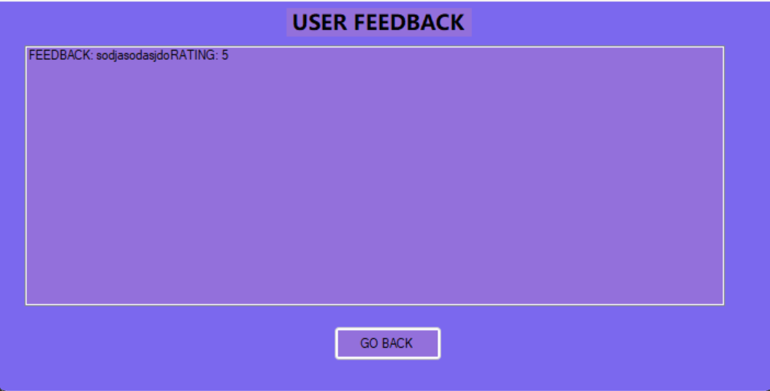

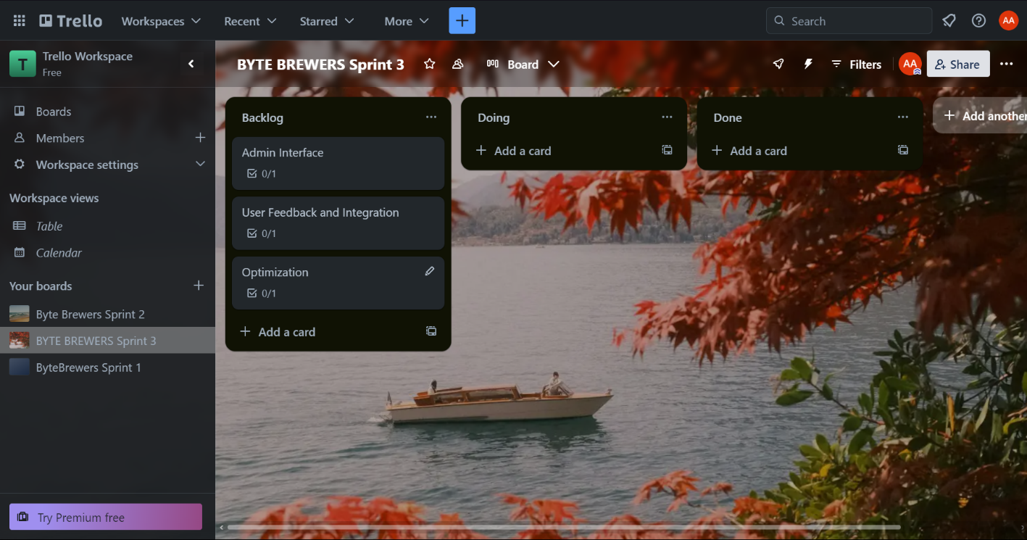 **TRELLO (SPRINT 3)**

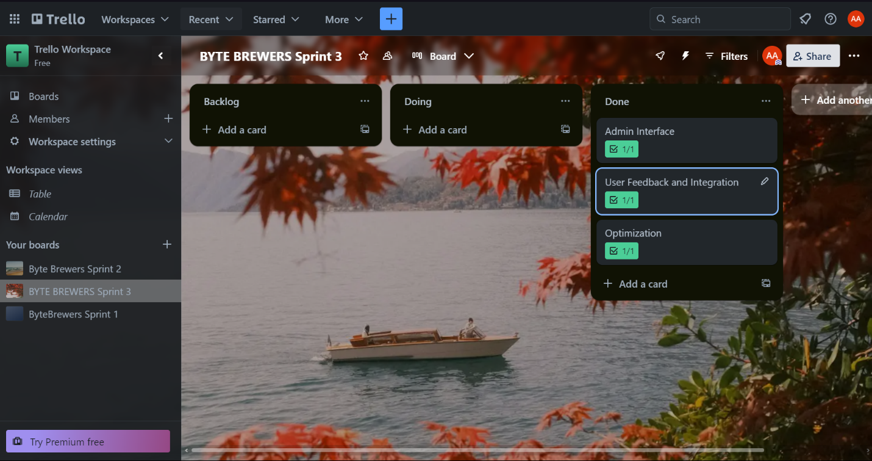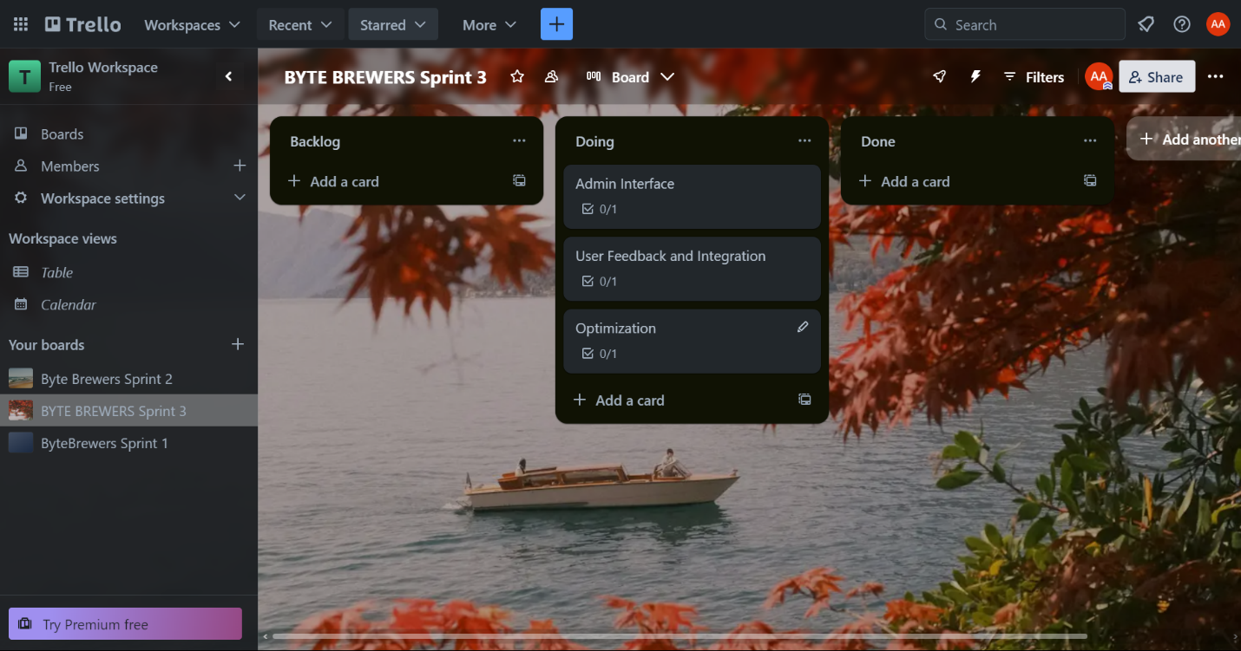

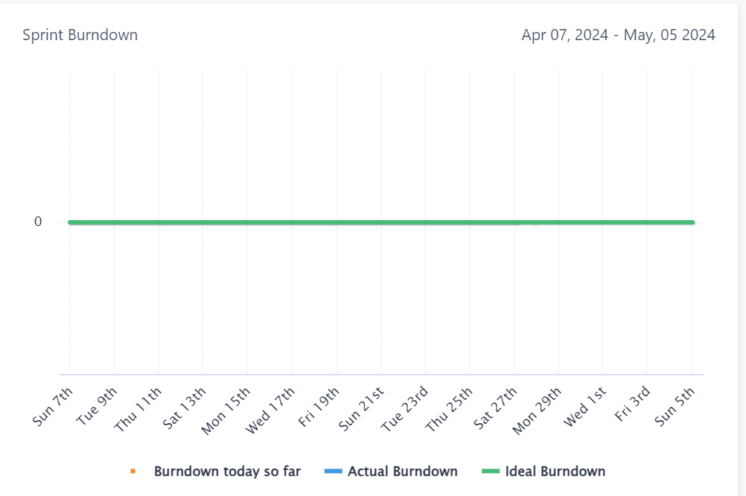 **BURNDOWN CHART**